
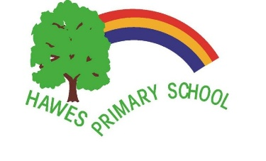

Hawes Primary Term and Holiday Dates - Academic Year 2025- 2026
Term | School Opens | School Closes
Autumn Term 2025 - first half term | Tuesday 2 September 2025 | Friday 24 October 2025
Autumn Term 2025 - second half term | Monday 3 November 2025 | Friday 19 December 2025
Spring Term 2026 - first half term | Tuesday 6 January 2026 | Friday 13 February 2026
Spring Term 2026 - second half term | Tuesday 24 February 2026 | Friday 27 March 2026
Summer Term 2026 - first half term | Monday 13 April 2026 | Friday 22 May 2026
Summer Term 2026 - second half term | Tuesday 2 June 2026 | Friday 17 July 2026
Please note –Monday 5th May – Bank Holiday

Staff Training Dates:
- Monday 1 September 2025
- Monday 5 January 2026
- Monday 23 Feb 2026
- Monday 1 June 2026
- Monday 20 July 2026

