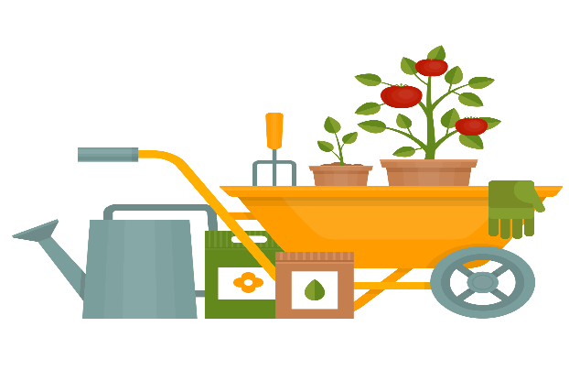
GARDENING CLUB
This Photo by Unknown Author is licensed under CC BY-NC
This week’s News!

We started this terms Gardening Club with a tidy up of the area that we use, sorting out the big storage box, put the flowering plants back and tied up the sunflowers. We hope to harvest the sunflower seeds from these to plant next year, as well as giving some to feed the birds.

Next week (weather permitting) we are going to be planting spring flowering bulbs.

A huge thanks to Bernadette Jones for donating the money raised from her crochet sales at Chapel Gallery, this has allowed us to purchase these bulbs, and will also enable us to get more winter flowering plants, tools and wet weather projects 🙂

Big thanks to Steph Donaldson-Coates for joining in the fun!

Thanks Ellie

