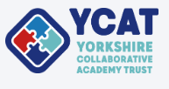

Online Safety Information Evening
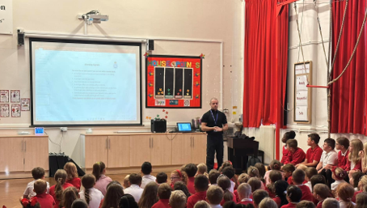
All parents from YCAT schools are warmly invited to attend this online information session, led by PCSO Martin Powell on:
Thursday 11th June
6:00 – 7:00 PM
Scan to join live via Microsoft Teams

Come along to learn about:
- Keeping children safe online
- Understanding apps, games and social media
- Practical advice for parents

- Join via teams: https://teams.microsoft.com/meet/320955217097168?p=WDFtthf1epv90OZfzl
