Handwriting at Hawes
At Hawes Primary School, we recognise the importance of children being able to write legibly, fluently and at a reasonable speed. As part of a high-quality English curriculum, we believe that promoting high standards of written language are essential in giving children the confidence to communicate competently and be prepared for the next stage of their education.
In the EYFS, children are taught to use the correct letter formation in letter families in discreet handwriting sessions. Children develop the use of effective pencil grip throughout their time in reception and learn how to sit for writing.
In Key Stage One, handwriting continues to be taught discretely, and practice focuses on ensuring that children form lower-case letters of the correct size relative to one another. In Year 1, children continue to write in print with the introduction of learning the explicit formation of capital letters.
From Year 2, children begin to be taught how to write in cursive script starting to learn to use the diagonal and horizontal strokes to join letters. They also develop accuracy in writing capital letters and digits of the correct size, orientation and relationship to one another and to lower-case letters and use spacing between words that reflects the size of the letters.
Transition from KS1-KS2 starts in the summer term of Year 2. Pupils begin to practice transferring their skills to using lined books with initial highlighter guides as opposed to handwriting lines. This support continues into Year 3 until pupils are confident writing without a guide.
Throughout Key Stage Two, emphasis is placed on children’s development of a cursive script. Children continue to be taught to use the diagonal and horizontal strokes needed to join letters and understand which letters, when adjacent to one another, are best left unjoined. There is a focus on writing legibly, fluently and with increasing speed.
Words and images used in handwriting lessons:
In relation to letter formation:  ascender descender  lower case upper case capital letter  diagonal join horizontal join  tram lines  top and bottom lines  position  letters sitting on the line  nip flip grip |  | 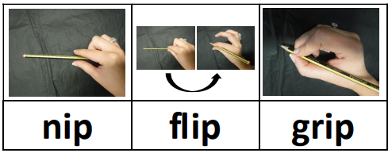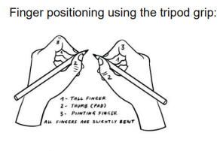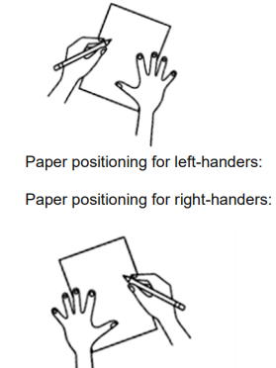
Step 1 – letter families | Curly Caterpillar Letters: c, a, o, d, g, q, e, s, (4 weeks) |  | Ladder Letters: l, i, t, u, (2 weeks) |  | One Armed Robot Letters: r, b, n, h, m, k, p (3 weeks) |  | Zig Zag Monster Letters: v, w, x, z (2 weeks) |  | More complex letters: f, j, y (2 weeks)
Step 2 – Capital letters – taught alongside a recap of the lower case | CC Letters: C,A,O,D,G,Q,E,S |  | L Letters: L,I,T,U |  | OAR Letters: R,B,N,M,K,P |  | ZZM Letters: V,W,X,Z |  | More complex letters: f, j, y (2 weeks) F,J,Y
Step 3 - The Joins | Join 1 – diagonal join to letters without ascenders  ai, am, an, ao, ar, au ca, ci, co, cu, ia, im,  in, io, ir, iu, ma, mi, mm, mo, mu na, nc, nd, ne, ni, nn, no, np, nu, ua, ui, um, un, uo, ag, aj, dy, ig, ip, lp, mp, np, ug, up  da, di, do, du, dy, ha, he, hi, ho, hu, ka, ke, ki, ko, ku, la, le, li, lm, lo, lp, lu  ac, ec, ic, lc, uc as, cs, ds, es, hs, is, ks, ls, ms, ns, ts, us  ce, de, ee, he, ie, ke, le, me, ne, ue |  |  | Join 2 - diagonal join to letters with ascenders  ab, ah, ak, al, at, el, ch, ck, cl, ct, eb, eh, ek, el, et  Ib, ih, ik, ill, it, kl, ll, ph, pl, pt, sb, , sh, sk, sl, st,  bu, ba, be, bi, bl, bo, br, bs,  th, tt, ub, uh, uk, ul, ut, |  | Join 3 – horizontal join to letters without ascenders  oa, oc, od, oe, og, oi, oj, om, on, oo, or, os, ou, ov, ow, ox, oy, oz  ra, rg, ri, rm, rn, ro, rp, rr, rs, ru, va, vi, vo, vs, vu  wa, wi, wn, wo, ws, wu, wy  oe, re, ve, we |  | Join 3 – horizontal join to letters with ascenders  ob, oh, ok, ol, ot, rt pu, pa, pe, pi, pl, po, pr, ps

